Bangalore City Guide

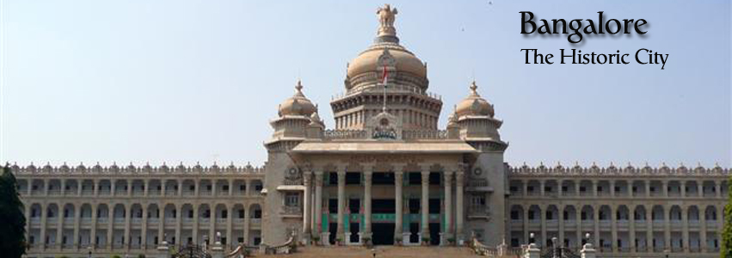

INDEX

- General Overview
- Housing
- Financial Services
- Healthcare
- Schooling
- Utilities
- Medial and Mail
- Telecommunications
- Transport
- Shipment of household Goods
- Expatriate Life
- Shopping
- Domestic Help

General Overview

Location & Geography:
Bangalore is the capital city of Karnataka, located in the southwestern part of the state on the Deccan Plateau. It stands at an altitude of 920 meters (3021 feet) above sea level. The city was founded over 400 years ago by Kempe Gowda, who marked its boundaries with four towers — now far surpassed by the city's expansion.

Area: Approximately 740 square kilometres

Background:
Bangalore is a perfect mix of tradition and modernity. Known as the "Silicon Valley of India", it's both a tech hub and a centre for arts, culture, and heritage. You’ll find a vibrant theatre scene, traditional art forms, and modern lifestyle co-existing in harmony.

Climate:
Bangalore has a pleasant climate throughout the year.

Summer: March–April, up to 39°C
Winter: January, as low as 14°C
Rainy Months: July and November (heavy rainfall)
Receives both southwest and northeast monsoons.

Time Zone
Indian Standard Time (IST) – UTC +5:30

Population & Culture:
Population: Approx. 9.5 million (3rd most populated city in India)

Languages Spoken: Kannada (official), English, Hindi, Tamil, Telugu, Malayalam, Tulu

Literacy Rate: 88%

National Holidays:

Republic Day – 26th January

Independence Day – 15th August

Gandhi Jayanti – 2nd October

Popular Festival Holidays:

Diwali
Dussehra
Eid
Christmas
Ganesh Chaturthi
Holi
Janmashtami
Maha Shivratri
Raksha Bandhan
Sankranti / Pongal
Ugadi
Vara Mahalakshmi

Emergency Contacts
Police: 100
Fire: 101
Ambulance: 102
Traffic Help: 103
General Info (Justdial): +91 88888 88888

Housing Overview
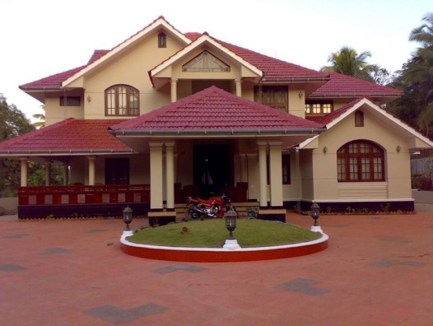

Neighbourhoods / Areas:

Bangalore had witnessed a stagnation / decline in rentals in the year (2009) following the market slow down, but now the market is once again picking up and certain communities have seen a raise in rentals once again. Bangalore has always been a Landlord’s market and the properties of expat preference come at a premium.
Take into account availability of transportation, traffic condition and commuting time to and from places where you need to go daily. It is advisable to have either a shared or sole-use car or driver or, hire chauffer driven cars to move around in Bangalore. The public transportation includes auto rickshaws and buses that are used by locals. However, we do not recommend these to the expatriates. The preferred expatriate residential areas are Sarjapur, Indiranagar, Koramangala, Central Business District, Whitefield, and Sadashiv Nagar. Expat communities in North Bangalore are fast developing due to the international airport and a large number of companies moving their offices to the Tech Park there.

Housing Options:

Temporary Accommodation:
There are quite a few 5-star and premium hotels in Bangalore like The Leela Palace, Taj West End, The Oberoi, ITC Hotel Windsor Sheraton and Towers. It is advisable to make bookings well in advance as the demand highly exceeds availability.
Long Term Accommodation:
The flats / villas / row houses in Bangalore are available in gated communities. This primarily ensures you of round-the-clock safety. Also, the apartment association assures a regular maintenance of the complex. In most apartments now-a-days they have 24-hour maintenance (electrical / plumbing / general maintenance), and a security and back-up generator. Club house facilities usually include swimming pool, gym, steam room, and sauna. A few of these complexes even have super-markets and ATMs within their premises.
In the case of independent houses, they are more spacious and one can enjoy privacy and peace. However, it is very essential to install security systems or hire a security guard. Most houses have their own private garden and terrace. But overall maintenance can be quite taxing.
As a matter of fact, the villa communities that have come up around Bangalore do provide an ideal solution. Being within a gated community and yet stand-alone properties, one enjoys the privacy of an independent house. They also have all the facilities of maintenance, security and club house. Some examples of villa communities in Bangalore are Palm Meadows, a project of Adarsh Developers and Prestige Group’s Prestige Ozone
Community Profile:
Breakdown of available properties:
• Houses – 20%: 17% furnished, 83% unfurnished
• Apartments – 80%: 15% furnished, 85% unfurnished
Houses:
Availability: Good
Detached: 30%
Semi-detached: 70% (approx.)
Style: Bungalows with front yard and 3-4 Bedrooms with attached bathrooms, kitchen + Living and dining area.
Average Age: 15-20 years
New construction: (5 years or less) 10%
Apartments:
Availability: Good
Located in: Small Buildings –65%
Large Buildings – 35%
Styles: More than 1 apartment on each floor. 1 fair sized master bedroom + 2 or 3 bedrooms and attached bathrooms, kitchen, living + dining area. Moderate size.
Average Age: 5-10 years
New construction: (5 years or less) 15%
The unique quality of housing in Bangalore is that in any area you will find properties to suit budgets that are low, medium or high range.
The above-mentioned residential areas have several parks and gardens, which you may visit for morning walks, leisure or children’s activities.
Visit the areas you are considering at various times of the day to get a clear picture of traffic patterns, noise, parking and distance to schools and work, measured in both time and traffic.
Serviced Apartments:
There are several serviced apartment options available in Bangalore. The service apartments can be classified under the following categories:
• Professionally run serviced apartments
These serviced apartments normally occupy a full block and have a dedicated house-keeping and management team.
• Stand Alone serviced apartments
Stand-alone serviced apartments is a new concept booming in Bangalore. This is not an organised sector as yet and sometimes you will find the quality well below standards in a few of these apartments.
• Guest House
Here a single room is rented out and the common facilities are shared with other guests. Not recommended to expatriates.
Check for the availability of internet, telephone, laundry, etc when you check in. Always ensure to keep your personal belongings and valuables locked away while you stay at any of the hotels or serviced apartments.

Rental Deposit:

In Bangalore it is a standard procedure to give 4 to 10 months’ rent as a security deposit. The security deposit is interest free and refundable at the end of the lease term.

Things to Consider Before Signing a Lease

Location plays a vital role in choosing the right place to live. Consider carefully some of the following:
Convenience
• Proximity to schools, work place and markets
• Entertainment and recreation
• Transportation and traffic conditions
• Medical facilities
Environment
• Old and developed / new and developing
• Apartment / independent house / villas
• Safety
• Neighbourhood
• Community
• Leisure facilities
Budget
Check well if the rental quoted is inclusive of apartment associated maintenance costs. If the Landlord is providing you with utility connections, the set-up cost is borne by the Landlord and the monthly rental and usage charges are borne by the Tenant. The monthly payment will have to be made directly to the vendors. Please note that there is always a due date for making payments.
When considering a property, keep in mind the following:
• General appearance of the property and its location
• Layout of the property
• Construction quality
• Age of the property
• Condition of all electrical appliances supplied including air conditioners, washing machines etc.
• Check humidity / mildew damage
• Is the telephone, internet line and gas connection provided by the Landlord?
• Facilities available within the complex (in case of gated communities)
• The security arrangement
Keep in mind:
• Negotiate with the Landlord for a notice period / diplomatic clause in the lease.
• Check for maintenance charges and move in, move out charges.
• Gardener’s fee.
• Club House membership – deposit and monthly usage charges.
• Power back up facility.
• Mosquito mesh on all doors, windows and ventilators.
• Grouting of tiles, if required.
• Geyser in kitchen.
• Aqua guard (water purifier) in kitchen.
• Painting of interiors and exteriors.
• Pest control of interiors and exteriors if you plan to take a house or villa.
• Check if the property has 24hrs security and maintenance services.
• Check all plumbing and electrical fittings.
Market practice and lease terms:
1. Typical lease period: 11 months
2. Deposit: 10 months’ rent
3. Rent in advance: monthly
4. Brokerage: one month’s rent
5. Lock in and Diplomatic clauses: negotiable
6. Lease registration: not mandatory as long as lease is for an 11-month period
Furniture Leasing

The furniture available for lease is pre-owned and the period of lease can vary according to one’s requirements. There is no guarantee and variety of furniture; it may vary from time to time. You can reach out to Kraft Mobility for a detailed information.

Financial Services Overview
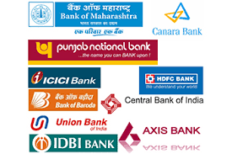
Currency:

The official unit of currency is the Indian Rupee. (Code: INR)
Coins come in denominations of 1, 2, 5 and 10 rupees. Notes come in 10, 20, 50, 100, 500 and 2000 rupees denominations.
Currency Exchange
Current exchange rates can be checked in daily newspapers, at banks, money exchange or on line. Foreign currencies can be exchanged at hotels and Government approved vendors throughout the city.

Credit Cards:

Credit cards are becoming more widely accepted, especially in the cities. Most banks issue credit cards with revolving and cash advance capabilities. Rupay, Master and VISA cards are widely accepted while American Express is not very common. It is best to check in advance before you carry out the transaction.
Note that there might be a transaction fee for using international credit cards in India. Please check with your bank for details.

ATMs:

Most routine money transactions are done on a cash basis rather than by cheque. A good ATM network is available throughout the city. 24-hour phone banking and credit cards are commonly used. There is no charge for using the bank’s own ATM. A service fee used to apply for cash withdrawals from other banks but not anymore. There is a daily limit for cash withdrawal from the ATM, which varies with banks.

Travellers Cheques:

Traveller’s cheques are available from most banks, local and foreign. US dollar and Pound Sterling are most common but some banks also offer travellers cheques in other major currencies. In buying or cashing traveller’s cheques, it is necessary to present your passport.

Opening a Bank Account:

Banks in Bangalore are categorised into government and private banks. The latter can further be classified into local and multi-national banks.
Please check with the bank on their business hours as they can vary from 10:00 – 14:00 to 08:00 – 20:00 on weekdays.
As a foreign national employed in India, binding to the Indian Foreign Exchange and Income Tax Law, you are restricted to opening 1 bank account per city.
While our relocation consultants will be able to guide you in opening your Personal Bank Savings / Checking / Credit Card account, each Bank will have a variety of differing benefits, which is entirely up to your personal choice / discretion:
• HDFC
• HSBC
• Citibank
• ICICI
• Standard Chartered
The documents required for opening a bank account vary. In general, the documents required are:
• An application form
• Copy of passport and Visa page
• Employer’s letter in India
• Lease agreement as proof of address
• Passport-sized photographs
• Residential Permit (RPRC)
The salary account, savings account, individual or joint account normally takes 2-15 days to open. An ATM card is usually provided upon request.
Internet Banking Services
All major banks in Bangalore offer Internet banking services such as balance enquiries, transfers and remittances.

Healthcare
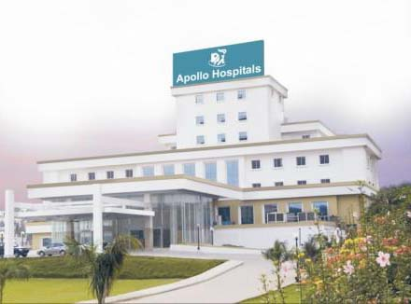
Prevention and Immunisation:

Health Risks
Cholera, dengue fever, dysentery, hepatitis, malaria, meningitis and typhoid are some of the health hazards. Many of India's larger cities are highly polluted and people with respiratory ailments may wish to take precautionary measures.
Be sure your routine vaccinations are up-to-date.
Routine vaccines, as they are often called, such as for influenza, chickenpox (or varicella), polio, measles / mumps / rubella (MMR), and diphtheria / pertussis / tetanus (DPT) are given at all stages of life.
Routine vaccines are recommended even if you do not travel. Although childhood diseases, such as measles, rarely occur in the United States, they are still common in many parts of the world.
The following are some of the recommended vaccinations for India:
Hepatitis A vaccine is recommended for all travellers over 1 year of age. It should be taken at least 2 weeks (preferably 4 weeks or more) before departure. A booster should be given 6-12 months later to confer long-term immunity.
Typhoid vaccine is recommended for all travellers. It is generally given in an oral form consisting of 4 capsules taken on alternate days until completed. The capsules should be kept refrigerated and taken with cool liquid. Side-effects are common and may include abdominal discomfort, nausea, rash or hives. The alternative is an injectable polysaccharide vaccine, given as a single dose. Adverse reactions may include discomfort at the injection site, fever and headache. The oral vaccine is approved for travellers who are at least 6 years old, whereas the injectable vaccine is approved for those over the age of 2.
Polio immunisation is recommended. Any adult who received the recommended childhood immunisations but never received a booster should be given a single dose of inactivated polio vaccine. All children should be up-to-date in their polio immunisations and any adult who never completed the initial series of immunisations should do so before departure. Side-effects are uncommon and may include pain at the injection site.
Hepatitis B vaccine is recommended for travellers who will have intimate contact with local residents or potentially need blood transfusions or injections while abroad. It is also recommended for all healthcare personnel and relief workers. A full series consists of 3 intramuscular doses given at 0, 1 and 6 months. Engerix-B is also approved for administration at 0, 1, 2, and 12 months, which may be appropriate for travellers departing in less than 6 months. Side-effects are generally mild and may include discomfort at the injection site and low-grade fever. Severe allergic reactions (anaphylaxis) occur rarely.

Medical Emergency Checklist:

It is important to know the location of the nearest hospital. Traffic jams in Bangalore can be more than a nuisance in an emergency. Generally, it is faster and more efficient to take your car or catch an auto rickshaw to the emergency room. When this is not possible, you may call an ambulance.
If possible, take someone with you to the emergency room to help with the registration and payment. You are expected to settle the bill at various stages of your treatment. It is important to carry some form of identification, like RPRC, with you all the time.
Expatriate Preferred Hospitals in Bangalore:
• Hosmat (Magrath Road)
• Mallya Hospital (Vittal Mallya Road)
• Manipal Hospital (HAL Airport Road, Whitefield, ITPL)
• St. John's Hospital (Sarjapur Road, Koramangala)
• Wockhardt (Cunningham Road and Bannerghatta Road)
• Sagar Appollo (Jaynagar)
• RxDx Clinic (near Cosmos Mall)
• Sakra Hospital (Outer Ring Road, Near Marathahalli)

Prescription Medications:

Medical Facilities:

Doctors, clinics, and hospitals are conveniently located and accessible. The cost of treatment is reasonable compared to almost anywhere in the world. Communication with doctors is usually not a problem unless you visit a government hospital.
The medical system in Bangalore is comprised largely of general physicians. In selecting a doctor, you may wish to consider which hospital he/she is affiliated with, in case of an emergency.
Pharmacies
Most medications can be purchased over the counter. Pharmacies are conveniently located throughout Bangalore. If you are currently taking some medication, it is important to alert your doctor of these in order to avoid being prescribed cross medication.
Some 24-hour Pharmacies:
• Metri Medicals: +91 80 2670 4534
• Mallya Hospital: +91 80 2227 7979 / 2227 7997
• Hosmat: +91 80 2559 3796 / 2559 3797
• Apollo Pharmacy, Koramangala: +91 80 4121 7156
• Manipal Hospital: +91 80 2526 6646

Emergency / Ambulance Service:

Emergency Ambulance Service: 102
Security
Tips:

Taxi drivers, auto rickshaw drivers or tourist guides are not very reliable. Always maintain a safe personal distance from them.
It is advisable to live in a community that has 24-hour security. If you do stay in an independent house, it is advisable that you hire a 24-hour security guard from a reputed agency.
Petty crimes do occur in Bangalore like chain and bag snatching. Avoid deserted roads even in the day time.
Do not venture alone into secluded places during night time. In case you are going out at night, always stay in a group.
Do not carry too much cash with you. Keep the excess cash as well as other valuable items in your room and lock them up properly.
Do not keep your wallet in the back pocket. It is better to keep it in the side pocket of the trousers or the jacket.
Always maintain decency and decorum while visiting religious places. Do not wear revealing clothes while at a temple or a gurudwara.
Always keep a photocopy of all the important documents, like passport, ID, residential permit, etc, with you.
Always gather some information about the places you are going to visit beforehand. It will prevent you from being misguided by others.
Pedestrians do not have the right of way, so be alert when walking or crossing the roads.

Police:

Police emergency number: 100

Schooling Overview
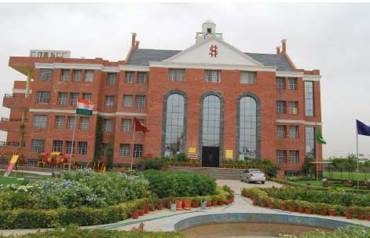
Bangalore Schools:

Education in Bangalore is available starting from Kindergarten to Higher Education level. Schools for young children are chiefly based on the kindergarten form of education. The schools are affiliated with a Board of Education like Karnataka State Board, Council for the Indian School Certificate Examinations, National Open School, International General Certificate of Secondary Education, and International Baccalaureate.
There are 3 kinds of schools in Bangalore - government (run by the government), aided (financial aid is provided by the government), and un-aided private (no financial aid is provided). After successful completion of secondary school, students take admission into Pre-University Courses (PUC) also known as Junior College. Successful completion of Junior College i.e. grade 11th and 12th, allows students to take admission into college for higher education. Large numbers of colleges are available in Bangalore; also, there is no lack of institutions in Bangalore providing post college education like Post Graduate Programs, Research Programs, etc.

International Schools:

With the expansion of Industrial areas in the region, there has been a growth in the number of international schools catering to the expatriate community. All schools welcome students of any nationality and each of the schools tries to reflect the international make-up of the school community within its curriculum.
• The Canadian International School (www.cisb.org.in)
• Bangalore International School (www.bangaloreinternationalschool.org)
• Indus International School (www.indusschool.com)
• Mallya Aditi International School (www.aditi.edu.in)
• The International School, Bangalore (www.tisb.org)
• Stonehill International School (www.stonehillinternationalschool.org)
The following are suggestions to assist you in making the best decision:
• Ask friends where they send their children and why.
• Telephone the schools you are interested in. Make an appointment to visit the school. Ask the admissions-in-charge to arrange for you to visit classrooms and speak with the teachers during your visit.
• Take time before the visit to list your priorities and questions.
• During the visit be attentive to how the child’s questions and behaviour are handled. What is the interaction between staff and your child? Is your child made to feel welcome?
• Inquire about the teacher / student ratio, the teachers’ credentials and teaching experience.
• Inspect the facilities – Look at safety features and overall sanitary conditions. Are the toys and equipment age-appropriate and adequate?
• Ask for a complete list of all fees before you register. Registration fees and subsequent school fees are non-refundable.
• Ask about transportation vehicles. How old are the buses or vans? Do not hesitate to ask about occupancy numbers and supervision.
Educating your child in a foreign country can provide a wonderful exposure to many different cultures and be a rewarding experience for both you and your child.
Parents should get some preliminary assessments about the possibility of admission prior to accepting an assignment. If your child has a slight learning problem or other disability then please be sure to inform the school during the admissions process to ensure that the school has an appropriate program for your child.

Language Schools:

Bangalore has always been well known for its schools and colleges. Many of these students and now the current working cospoliton citizens aspire to go abroad to either study or work. For such reason Bangalore has many private institutes that teach various languages. To name a few:
Alliances Francis - French
Max Muller Bhavan - German
Inlingua - English, German, French, Spanish
Japanese Language School
Value point Academy - English
Institute of Indian and Foreign Languages - German, Spanish, French, Italian, Russian, Portuguese, Japanese, Chinese, Korean, Hindi, English
Institute of Spanish Studies
Bangalore School of English

Utilities Overview
Electricity:

The charges for electricity are relatively high and the charge per kilowatt-hour increases with the volume consumed. The due date to make payment is printed clearly on the bill. It is advisable to make the payment prior to the due date. The electricity companies will cut electrical supply to your property if the bill has not been paid. The bill can be paid at power supply department offices closest to your residence. Ensure to ask your relocation coordinator for the office location closest to your property.
Voltage:
Electricity in India is 240 Volts, alternating at 50 cycles per second. You will require a voltage converter if you are carrying a device that does not accept 240V at 50 Hertz. To adjust your device according to the power and voltage in India, the following 3 types of Voltage converters may be used:
Resistor-network:
This type of converter usually supports approximately 50 -1600 Watts. They are lightweight. You can easily use this converter for high-wattage electrical appliances like hair dryers and irons. But, you can use them for short periods only and they are not ideal for digital devices.
Transformers:
Transformers support low watt rating, around 50 – 100 Watts. Generally, you can use them continuously. Also, they provide better electricity for low wattage appliances like battery chargers, radios, laptop computers, cameras, mp3 players and camcorders. Their drawback is the low wattage and heavy weight.
Combination:
Combination converters are also manufactured by some companies. They are a combination of a resistor network and a transformer in the same package. You can easily switch between the two modes. If you need both types of converters, then it is better to buy this combination converter.

Water:

If you are living in an independent house, you will receive a monthly water bill. The payment due date will be specified on the bill. It is advisable to make payment prior to the due date. You can pay the bill at the nearest Water Supply Board Office. Please check with your relocation coordinator for the exact location of the office closest to your residence.

Garbage Disposal:

Door to door collection of garbage is available in most localities in Bangalore. This is normally a daily collection. In gated communities however, there could be particular days when the garbage is picked up.

Other:

Gas (bottled)
Bottled gas is available from neighbourhood suppliers at a cost ranging from Rs. 350 to Rs. 800 per gas bottle. For the initial connection, a refundable deposit amount along with nominal charges will have to be paid to the agency. They may also require some document with proof of address for filling out an application form.
Normally every household has a minimum of 2 gas bottles. When the first gas bottle is emptied, place a call to the gas dealer, provide your consumer number and request for a new bottle. The new bottle will take a few days to be delivered. When they come for delivery, cash payment for the new bottle will have to be made and the old empty bottle returned.
Pest Control
Keeping in mind that India is a tropical country where cockroaches, flies, and other insects exist, we require periodical pest control for hygiene.
Pest control services are available and can be contacted for regular pest control. Please be sure that the medicine used is approved by the World Health Organisation.

Media and Mail Overview



Television:

Cable and Satellite
Once you move into your property, the community cable network personnel will pay you a visit. He will request for a nominal fee towards providing a new connection. Set up normally takes about 2 days. Thereafter a monthly charge will be payable in cash. He will issue a receipt towards the same. All major channels like STAR, ESPN, HBO, National Geographic and Discovery are available. Contact your cable operator for a complete list of available channels.
Satellite services can be obtained through TATA Sky and Dish TV, Big TV, Airtel. There is an initial set up fee which includes cost of dish, receiver, and a yearly subscription. The DTH (Direct To Home) satellite service set up will take 2-5 days depending on the availability of technicians. All major channels are available and your provider can give you a complete list of channels.

Radio:

There are several radio channels available with no cost payable. You can tune into any of the radio channels using your radio set.

Newspapers:

There are several newspaper dailies in English (The Hindu, The Times of India, Deccan Herald, etc), Kannada and Hindi available in the city. The cost of each daily varies and one can either
1. pick them up from the various stalls in the locality or
2. subscribe online or
3. subscribe with the local newspaper distributor

Post Office:

Letters, cards, telegrams, speed post, courier services, etc can also be used as a means of communication in Bangalore
Post offices are located close to most residential areas, the Postal Services that they provide are:
1. General postage of letters and parcels
2. Speed post
3. Logistics post
4. Business post
5. Direct post
6. Registered post
7. Money orders
8. International money transfers
For more information on these services and rates, please visit the local post office in your area.

Telecommunications Overview
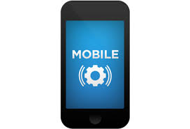
Telecommunications:

Telephone connections are available through the government service provider- BSNL or private service providers like AirTel, Vodafone and Jio. The government service provider will take 7 - 14 days for set up whereas the private service provider will take about 2 - 5 days for set up. The documents required include the application form, photographs, address proof and passport copy. A refundable deposit amount is payable apart from the installation cost at the time of submission of application. Please note that in the case of private service providers the line gets disconnected once calls are made equivalent to the deposit amount before the expiry of the billing cycle. The bills are raised on a monthly basis and the due date will be provided in the bill. It is advisable to pay the bill prior to the due date to avoid disconnection. The bills can be paid at the offices of the service provider or various bill payment centres.
Please note that these service providers offer various packages based on usage limits. You can select the most ideal and suitable package. Packages may be changed at a later date. If you did not receive your phone bill, you can get a statement of your account by going to the service provider’s office. Some Landlords provide you with a telephone connection. In this case you will not incur any set up cost but the monthly rental will be borne by you.
International calls:
All the service providers permit you to make international calls. Please request your service provider to activate this feature at the time of application. Please contact the service provider for the international calling rates. The prefix for international call is 00.

Public pay phones:
Public phone booths displaying PCO / STD / ISD signs are rarely available in Bangalore.

Mobile Phones:
In Bangalore, the GSM service providers are Vodafone, JIO and Airtel. These service providers offer a variety of post-paid packages based on usage schemes. There is a nominal deposit amount payable along with the activation fees. Additional deposit is required for international roaming services. Pay as you go services (prepaid) are available and the cards can be purchased from local vendors across the city.
Following the government regulation, a valid photo ID and proof of address are required for new subscriptions.

Internet:

Internet service can be availed through the following providers: Airtel, Jio, Tata Fibre, BSNL.
These service providers offer broadband connectivity via wired telephone lines. Once you have selected your residential property you will have to check with the service provider for coverage in your area. Again, these service providers offer a variety of packages based on usage.

Transport Overview
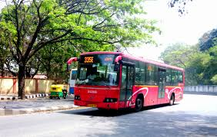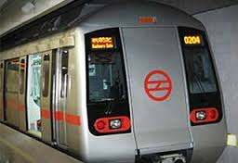

Public Transportation:

In Bangalore, the following modes of transport are available to travel within the city:
• Cabs / Chauffer driven cars on hire (Mobile Application based OLA, Uber, In Drive)
• Auto rickshaws (autos)
• Buses
• Citi-taxis
• Metro, currently service is available in select areas

We recommend the usage of cabs / chauffer driven cars on hire to expatriates.

Citi-Taxi
There are several cab agencies that operate metered vehicles across the city. To book you must call the cab company and provide the address and contact number. They will provide you with a cab based on availability. Most of these drivers may not be fluent in English. They are also known for their rash driving.
Please ensure that you check all your belongings before you leave the cab. It is not advisable for women to travel alone in these cabs late at night. If for any reason you do not feel comfortable with your taxi driver, do not hesitate to ask him to stop. Pay and get out immediately. If you are a foreigner the taxi driver might demand a generous tip. Please note that it is not mandatory to tip the taxi driver.
• Uber (app-based cab service)
• Ola Cabs (app-based cab service)

Buses
Bangalore Metropolitan Transport Corporation (BMTC) runs bus services for traveling within the city. A number of private operators also ply buses in the city. The buses are usually crowded, but now there are air-conditioned buses which are quite comfortable.
Auto Rickshaws
The main mode of local transport in Bangalore comprises of the auto rickshaws. Always insist on going by the meter and do not pay even a rupee extra than the amount being displayed on the meter. In case the meter is not working, fix the fare in advance. The drivers will demand 1 and a half to 2 times the meter after 21:00 hrs and before 07:00 hrs.
Airport:

Name: Kempe Gowda International Airport
website: www. https://www.bengaluruairport.com/
Location: It is 4 kilometres (2.5 mi) south of Devanahalli and is 40 kilometres (25 mi) from the central business district of Bangalore
Connectivity
As an alternative to taxis, passengers can use car rental services.
Auto rickshaws are not allowed beyond the trumpet interchange leading to the airport, but passengers can get dropped off at the trumpet interchange by an auto rickshaw and then use an airport shuttle bus from the interchange.
Shuttle service provided by the Bangalore Metropolitan Transport Corporation (BMTC), connects parts of the city to the airport. This service is known as Vayu Vajra. BMTC runs nine routes using its fleet of Green Volvo buses. These buses make 251 trips in a day. Vayu Vajra is a 24/7 service. All Vayu Vajra services have route numbers designated with a KIAS prefix.

Car Rental:

International car rental companies and a number of local firms operate in Bangalore.
Few of the car rental companies are:
• Orix:
• Kraft Mobility
• Hertz
The cost to rent a car varies from company to company. Some of these companies offer cabs on self-drive option. However taking into consideration the traffic condition in Bangalore, this is not advisable.
In the case that your company is tied up with a car rental agency, use this facility to enjoy the contracted rates. Do remember to note down the meter reading and time when the car signs in and off. In case you pay for the parking, remember to keep the parking bill or make a note in the duty slip. It is not mandatory to tip the driver however most people do give nominal lunch / dinner money depending on the length of usage. Please note the billing for the car rental will be done from the time the car leaves the garage until it reports back to the garage.

Driving and Licences:

It is not recommended to drive in Bangalore if you are not familiar with the traffic conditions. Most roads are not well paved and people generally do not follow traffic rules. Lane driving is also not followed and the distances and unruly traffic are generally stressful and tiring.
In the case you own a car, it is best to hire a driver. Otherwise, there are several car rental companies that provide chauffer driven cars. Taking into account the distance, traffic condition, pollution and lack of public transport appropriate for expatriates, a car is a must to travel around in Bangalore.
Importing an Automobile
Importing a car to India is possible but expensive. Regulations on imported vehicles are strictly enforced. Check with your shipping agent well before contemplating shipping your vehicle to Bangalore. Do note that import of cars incurs significant expense and hassle. Import duty is approximately 150% of the CIF (cost, insurance, freight) value.
Purchasing an Automobile, Motorcycle or Motor Scooter
If you decide to purchase a car in Bangalore, please research the following points:
• Safety features
• Mileage
• Prices from multiple car dealers
• Re-sale value
• Availability of easily accessible service centres
• Maintenance cost
• Air-conditioning
You also have the option to purchase used cars. Please check ownership documents thoroughly and use a trust-worthy agent.

Cars and bikes can be hired on rent as well from the given companies:

• Zoom Car, app based self-driving car rental company
• Myles, app based self-driving car rental company

HHG Shipment Overview
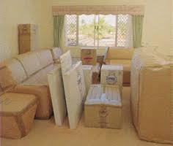
Household Goods Shipment

Indian nationals and foreign nationals, including those of Indian origin, transferring their residence to India or coming to India on employment, can import their personal effects and household goods into India free of duty. This is subject to the following conditions:
• Owner of the goods if Indian national, must have lived overseas for at least 2 years and must be transferring his/her residence to India. Indian nationals must not have visited India for more than 180 days in the preceding 2 years.
• Foreign nationals must have a Work Visa valid for minimum 1 year. They should complete the registration with the FRRO and procure the Residential Permit which is required to clear the shipment. Please note that the original passport is required at the time of custom clearance.
• Sea shipment must be shipped within 30 days of arrival and air shipment must be shipped within 15 days of arrival of the owner into India. Cars can be shipped within 6 months of arrival. If there is a delay then goods can be cleared only if customs condone the delay. Each case will be decided on merits.
• The owner should have arrived into India before shipment arrives else demurrage / container detention will be quite heavy. The condition of a compulsory 1-year stay in India after claiming Transfer of Residence duty benefits has been removed, and importers can now leave the country after claiming TR concessions.
Household Goods:
• Duty free imports: Old and used personal effects and house-hold goods such as clothes, books, kitchenware, furniture small appliances like mixer, juicer, iron etc. are allowed to be imported free of duty if these are used by the shipper, provided the client has a valid 1 year Visa.
• New articles, with the exception of those below are charged duty at 35%. The following items (1 of each) are charged duty at 15% of the value subject to a value limit of Rs. 500,000 / - (approx. US $ 10000) regardless of usage.

The items are:
TV
DVD player
Video home theatre system
Dish washer
Music system
Air conditioner
Deep freezer
Microwave oven
Video camera
Word processor
Fax machine
Portable photocopier.

Duty Free items:
Laptop / desktop computer
Refrigerator up to 300 litres
Washing machine
Cooking range
VCR / VCD

Concessional duty rate of 15% is allowed only on the first unit. If the shipper has 2 or more of any item or appliances, or the combined value of the appliances exceeds Rs. 500,000 ($10000), duty at 35 % will be charged on the additional units / value.
Import duties on alcohol, wines, spirits, etc are very high in India (approx. 200% of the value assessed by customs).

Expatriate Life Overview

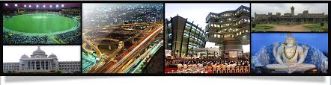

Expatriate Groups
The Overseas Women’s Club (OWC) of Bangalore is a social and charitable organisation of women from many nationalities and cultures. They are a welcoming group, happy to greet new members and provide guidance as you make your transition into a new culture and a new city. As Bangalore grows, so does their membership, providing wonderful opportunities for making new friends from all over the world, while enjoying a cup of coffee on Thursday mornings at the Leela Palace. If you want to learn something new about the vast city where you have relocated, then you can join the monthly meetings held on Monday mornings at the ITC Windsor.
There are many activities, social events, and fund-raising opportunities. Several of their events are designed specifically to raise funds for the many charities they support.

Entertainment and Leisure

Bangalore stands out as the IT capital and Silicon Valley of India, and thus dedicated and skilled professionals reside in this city. But even professionals do get tired due to the hectic lifestyle and therefore the city offers numerous leisure activities and relaxation. So, if you love watching movies, clubbing or just relaxing by the pool with all your family, you are able to do each one of these in Bangalore.
There is no lack for the way of entertainment in the city of Bangalore. Right from pubs to shopping malls, auditoriums to art galleries, there is something to keep everyone entertained. Actually, Bangalore is undoubtedly identified as the centre of entertainment and leisure.
Bangalore is known for a flourishing culture of the club and many of its clubs have a history dating back to the days of the British. In recent times, several clubs and resorts have sprung up in the city of Bangalore. Simultaneously, several older clubs such as Bangalore club, Century Club, etc. still provide local as well as tourists with many choices for entertainment in Bangalore. People interested in golf can visit the Eagleton Golf Club or the Karnataka Golf Association.
Cinema Halls
One mode of popular entertainment in Bangalore includes the many cinema halls (theatres) and multiplexes dotting the city. Really Bangalore is without doubt one of the first cities where the concept of multiplexes was introduced. Many Cinema halls are located close to the restaurants, providing the total entertainment package for the whole day. PVR Cinemas, Vision Cinemas, INOX are few important Multiplexes of Bangalore.
Shopping Malls
The Bangalore city is a shopper's paradise. Starting from inexpensive roadside things to branded items you will get more or less everything and anything in this city. Bangalore is also filled with shopping centres as well as shopping malls, providing commercial outlets, restaurants including a kiddie’s corner, all in one roof. Phoenix Market City, VR Mall, Forum Mall, Garuda Mall, Mantri Mall and Gopalan Mall are few important shopping malls of Bangalore.
Auditoriums
The cultural side of Bangalore is reflected in the many auditoriums which have been established in the city. Right from dance programs to musical programs to plays, the auditoriums in Bangalore will certainly make happy the creative side of people.
Art Galleries
Art lovers who visit Bangalore usually do not despair. There are numerous art galleries in Bangalore that showcase beautiful pieces of art. Bangalore art galleries also serve as a showcase for people to come face to face with all the immense expertise of local artists.
Visitors may also visit the amusement park with their family to enjoy their weekend. You will get many entertaining things like the video games, bowling, etc., in the amusement park. There are many slides which are kept here for the entertainment of children.
Outside the City
The geographical location of Bangalore makes it an ideal location for people to travel to various parts of South India.
The topography of the areas around the city provides opportunity for nature and adventure lovers.

Shopping Overview

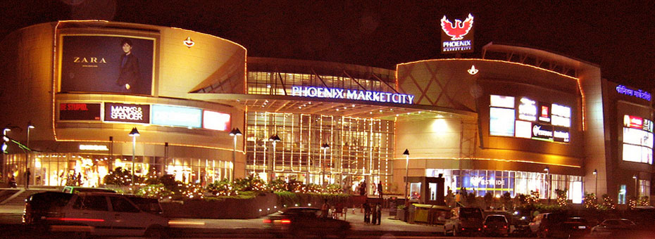

Shopping in Bangalore city is one remarkable experience one wishes to have too often.
Bangalore, the capital of Karnataka, is one of the most vibrant of the Indian metropolitan areas. Being the information technology hub of the country, with a large, young working population, it boasts of mix of a cosmopolitan and traditional culture. The city is dotted with shopping areas, big department stores and glistening new malls. Everything from apparel, footwear, jewellery, to traditional silk and sandal wood handicrafts are available in the city making it a shopper's paradise. Apart from the traditional items such as silk fabric and saris, antiques, ivory carvings and handicrafts, trendy designer wear and the high-end consumer items, electronic goods, and cars are also part of the Bangalore shopping experience.
Bangalore has traditional markets with shops aligned on specific roads as well as malls which have any number of shops within them. The popular shopping areas are in the roads which lie around the central business district.
Vittal Malaya Road
This is one of the high-end shopping areas of the city. Shops and department stores stock international brands such as Versace and Louis Vuitton.
M G Road
This shopping area is in the heart of the city and one of the most popular with the tourists. It was earlier known as South Parade and is an important landmark of the city. Shops stock everything from traditional crafts, to apparel, footwear and curios. Shopping complexes, bookshops, and department stores- all are located on this road.
Residency Road
Close to M G Road, this road has many state emporia and other shops selling handicrafts, furniture and antiques.
Brigade Road
One of the busiest commercial and shopping areas in the city, this road connects M G Road to Hosur Road. Shops, pubs, eating places and restaurants dot this road. This place is most popular with the young crowd with shops stocking electronic goods, garments and accessories.
Commercial Street
Close to the central business district and the Vidhan Soudha runs this road with shops selling designer products, international brands and high-end life style products. Also, one finds book stores, art shops, jewellery shops and textile retailers here. As this is the busiest commercial area in the city, tourists and locals throng the shops here.
Sampigne Road
Located at Malleswaram, this road has a flower and a fruit market. Shops stock silk sarees, handicrafts, religious trinkets and material, traditional sweets and cloth.
Gandhi Bazaar
It is one of the oldest shopping areas in the city. One can buy traditional items, fruits, groceries, and silk saris. The range of products one can shop here is from apparel, cloth, and plastics to electronics and house hold goods.
Chikpete
This is a narrow street market place in the old city. Shops selling silks at bargain prices are a tourist attraction. There are also gold and silver jewellery shops here.
Apart from the above, all localities have a market of its own with various shops and super markets.
The mall culture is also quite big int he city. Some of the popular malls in the city are:
Phonix Market City (East)
Garuda Mall (Central)
Forum Mall (South Central)
UB City (Central)
Orion Mall (North West)
Mantri Mall (West)

Domestic Help Overview

Household Assistance – Maid Services
This is a highly unorganised sector in India. The best way to identify household help is through references or from a repatriating family. The next option is to tap your resources at the expatriate network. Commonly in India, once you move into your house, the community watchman will assist you in finding a maid. There are a few agencies that provide assistance in finding household help but they can be unreliable. As per their standards they have to conduct background checks and police verification but this is not accomplished in most cases.
The concept of a nanny is not very popular. Most families train their maid to look after the children for short periods of time. If you are an expatriate, the household help tend to demand more money as salary. It is also common for them to request you for a loan or small sums of money on a daily basis for traveling, food, etc. Please try and refrain from giving them money apart from their salary and festival bonuses. Always keep your valuables locked and supervise them as much as possible.

